Framework of using artificial intelligence to meet the needs of the elderly in smart interior design.

Christine Ezzat Danial ¹* and Girges Sidhom ²

ABSTRACT

Abstract—Smart interior design incorporates artificial intelligence (AI) so that the needs of the elderly could be met and their quality of life enhanced to help the latter live comfortably in old age. Artificial Intelligence, home technologies, and Internet of Things (IoT) can meet the physical and mental needs of elderly people. Such technologies ensure health surveillance, enhance security, and engage in individualized care, and therefore, they form part and parcel of smart elderly care facilities. Major dimensions of application of AI in smart-interior design to elderly people are examined in the current investigation. Intelligent interior design can be improved immensely using AI technologies so that the lives of the elderly are made as desirable as possible by the creation of spaces that priorities safety, comfort, and independence.
That's why the research applies smart interior design steps that meet the safety and requirements of the elderly using AI technologies, and the final framework on architecture plan and using AI software to generate photos that show centered design solutions for elderly and the smart interior design elements to suit the elderly on one of the needs or health challenges

Keywords: Artificial Intelligence, Smart interior design, Elderly living, Aging in place, Design requirements, Intelligent elderly care, Human-centered design

INTRODUCTION

All life has equal values with each other and no loss of human rights even in old age. The proportion of elderly citizens in this world will grow up to 12% in 2030 and 16% in 2050 [1]. The rate at which population becomes elderly varies from nation to nation with specific increase evident in poorer, middle-income countries such as China and Brazil [2]. Changes in the urban living as well as the wider social trends are having an effect of how elderly people are distributed in rural and urban areas [3]. Elderly people find it difficult to access quality healthcare, favorable social surroundings, means of transport and systems that enhance their independence and participation in the society [4]. The “Decade of Healthy Ageing,” of the United Nations, advocates for the generation of age-friendly societies across the world for retaining dignity and encouraging seniors [5], [6]. There is an emerging science of effective care for the elderly and principles of designing interiors for seniors [7], [8].

The mental health of elderly people’s faces significant risks from social isolation and loneliness because the conditions make their bodies more vulnerable to developing anxiety and depression [9]. Every sixth elderly person faces abuse with caregivers normally responsible for their mistreatment. Mental health disorders exist in 14% of adults who are 60 years and older making up 10.6% of disability years in this population [9]. Technology and medical progress together with environmental elements drive up the elderly population worldwide [10]. Future analysis shows a growing emphasis on environment design that caters to elderly needs and the adoption of universal design methods in building.

The research problem is lack of foundational and interior design in most homes which elderly are lived in, to compatible with the optimal health status of this group of elderly people. In light of technological developments and artificial intelligence, solutions must be sought and adapted to help the elderly live safe lives.

Therefore, the research question is how to integrate smart home technologies into the interior design to aid aging adults with the sustainability of independently living. The goals include acquiring essential smart technologies in terms of promoting safety, convenience, and comfort. Estimate effectiveness, feasibility and acceptance of such technologies as well. Also, find the obstacles to their adoption and incorporation then. In addition, present targeted suggestions about designing inclusion AI and accommodating smart home settings.

____________________________________________________________
¹ Department of Architecture, Faculty of Engineering, El Shorouk Academy, El Shorouk City, Egypt
² Department of Architecture, Faculty of Engineering, Cairo University, Cairo, Egypt
* Corresponding Author

II. Materials and Methods

A. Research problem and Question

Most of the buildings or centers designated for the elderly people in general and for those that are likely to suffer from reduced mobility in particular lack the basic foundations and interior design criteria conforming to the optimum health status of this category of old people. These standards are supposed to address their functional, health, and psychological needs along with their physical limits towards making provisions of safety and security standards.
So, the question becomes:
- How can we help the elderly, who suffer from various illnesses and needs, live and continue their lives within the context of basic design principles?
- How can we use artificial intelligence (AI) to meet the needs of the elderly in smart interior design?

B. Methodology

The research methodology followed the scientific approach, as shown in Figure 1.
- Descriptive approach: This approach identifies the characteristics of elderly peoples to determine their psychological and physical needs and uncover the spatial barriers that affect their environment, through a literature review.
- Analytical Approach: Applying Smart interior design steps that meet the safety and requirements of the elderly using AI technologies, and the final framework on architecture plan and using AI software to generate photos that show the smart interior design elements suit the elderly on one of the needs or health challenges.

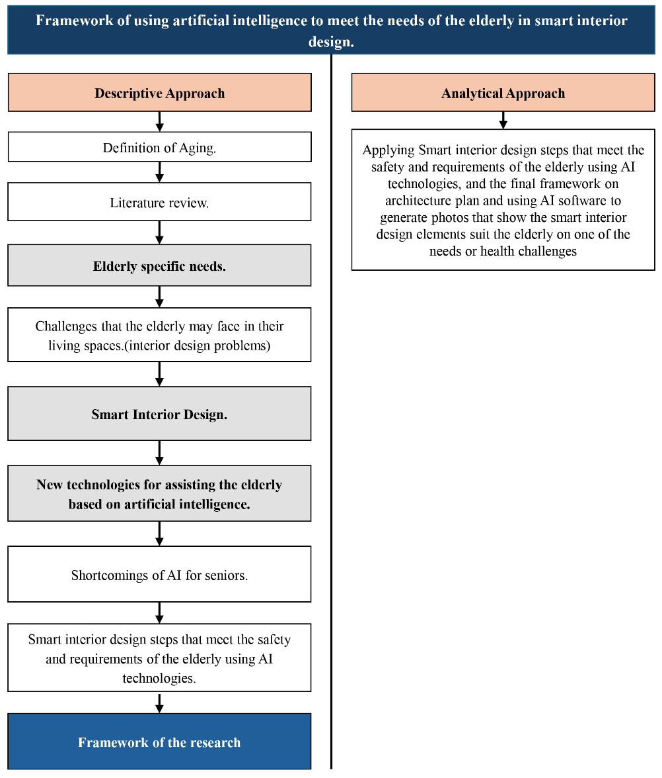
- The research methodology
Source: Researchers

C. Methodology

Elderly people are referred to as people whose physical and mental functions start deteriorating significantly from their earlier stages of life. Based on WHO’s Expert Committee in the year 1972, 65 years was given as the beginning of the elderly, similar to most countries’ retirement age [11]. A person is considered to be elderly in Egypt when he is 60 years old in legal terms.

D. Literature review

Daud et al., agreed that the research focus on the importance of AI in predictive healthcare and increasing the performance of healthcare services to the elderly. The article aims to understand the smart home technology use to improve interior design and ergonomics, accessibility, and psychological well-being, which affect quality of life [12].

Hou et al., dwells on Artificial Intelligence-based Activity Recognition (AR) as a mean to track Activities of Daily Living (ADLs) in smart homes. As a way of improving the well-being of the elderly by predicting their behavior and directing health data to family and caregivers, therefore, ensuring a better outcome of their living [13].

Shu et al., argued in relation to smart interior design towards the elderly, artificial intelligence can be used to improve smart design of the living environment to be tailored towards the individual and become more user friendly (safety), convenient and comfortable. This method can develop their interaction and decrease the level of loneliness and promote a contemporary aging community [14].

Zhao Intelligent elderly care interior design makes use of artificial intelligence to maximize functionality, convenience and safety to satisfy the psychological needs of elderly people. This encompasses smart home systems, easy and convenient designs that enhance independence, comfort and better-quality life. The focus of the article is the relationship between the psychological needs of elderly and the design of interior smart elderly care. The features of the psychological needs of elderly people and the theoretical and practical aspects of intelligent elderly care interior design are examined, reviewed in literature and checked in empirical research. The research result showed that the interior design of smart elderly care is connected with the psychological needs of the elderly and that the happiness and quality of lives of the elderly can be increased through satisfying their psychology needs. It is on this premise that optimization strategy of intelligent elderly care by interior design based on the psychological needs of the elderly is proposed [15].

Wang et al., concerned with the computer simulation and the human-computer interaction algorithm as the method to design the aging-friendly interior with references to the elderly preferences in the anti-slip measures, intelligent door locks, handrails and the particular needs of elderly people in the interior design of smart apartments [16].

Visionary design elements in apps can greatly improve the usability of smart home technologies as experienced by the elderly people. The important ones are interface navigation, color schemes, and data visualization, among others, which all serve both cognitively and physically oriented needs of elderly people [17], [18], [19].

E. Identifying Elderly Specific Needs

Elderly people need to know all of their requirements as much as healthcare is concerned in an effort to get good health. Needs of the elderly can be broken down into various categories as shown in Figure 2 [20].

- Physical Needs
- Accessibility: Facility for mobility without constraint by utilizing ramps, lift and wide corridors.
- Safety: No-slippery floor, fall-detecting devices and well-lit room.
- Ergonomics: The equipment and furniture have conformed and eased according to their physical strength.

- Psychological Needs
- Mental Health Care: Spaces for Tension Release and Relaxation.
- Social Interaction: Spaces where human beings can go to in order to fight loneliness.
- Personalization: known and customized UX elements.

- Health and Medical Needs
- Provision of medical facilities.
- The patients who need to undergo intensive health care management can enjoy remote health care monitoring using intelligent system technologies.
- Some of the needs must include design characteristics contributing largely to the rehabilitation of physically injured patients.

- Social Needs
- Being able to engage in the community.
- Inter-generational play spaces.
- Dignity and respect for self in the area.

- Technological Needs and Sustainability Needs
- Integration of the E-intelligent machines for easy use.
- Having the green sustainable building materials and efficient energy design.

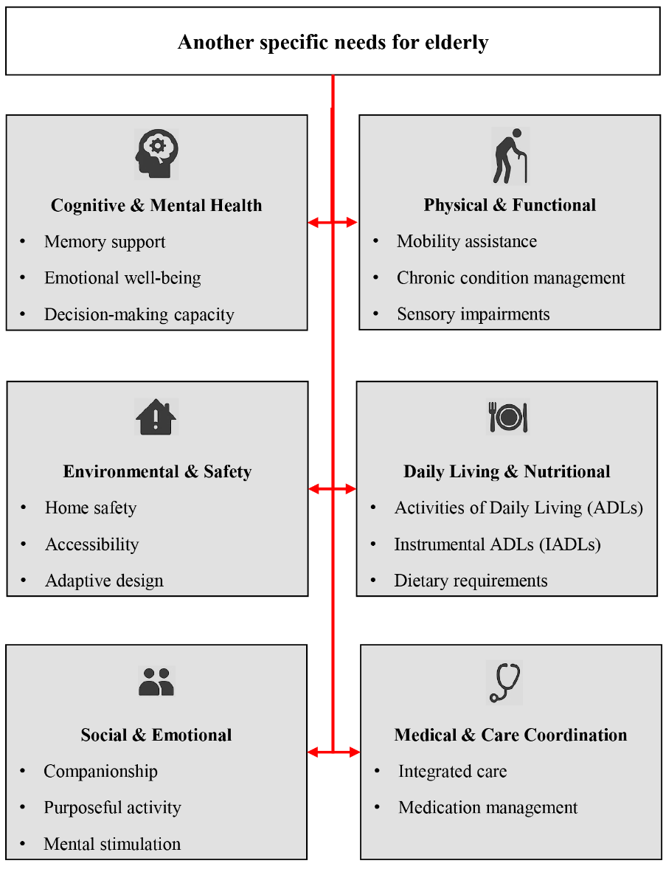
- Another specific needs for elderly
Source: Researchers

F. Challenges that the elderly may face in their living spaces

Elderly people are likely to have different sets of problems in their surroundings that may impact on their safety, comfort, and independence [21]. Physical issues include mobility restriction, inability to negotiate stairs or tight passages because the person is weak or plants his or her feet wrongly and his or her inability to open doors or manipulate things resulting from weak grip. Difficulties with one’s cognitive functions, including memory loss and confusion may make wayfinding or navigation around familiar spaces challenging, especially in a cluttered environment. Sensory deficits such as poor vision, inability to hear, and discomfort in relation to the use of some of the materials also pose a challenge. Emotionally, limited access to social spaces can result in isolation and struggle with the environment could cause stress and frustration. Design related obstructions include un-reachable features such as high shelves or small doorways, and the absence of safety features such as grab bars and also low-quality lighting. Careful planning solutions like the application of universal design principles, glare-free lighting, non-slip surfaces and ergonomically friendly designs can make a huge difference to their quality of life [22], [23].

The following Figure 3 show the movement of the elderly in a wheelchair or using crutches. This requires passageways that allow movement as one of the design solutions that must be provided to them by removing obstacles and rearranging furniture.

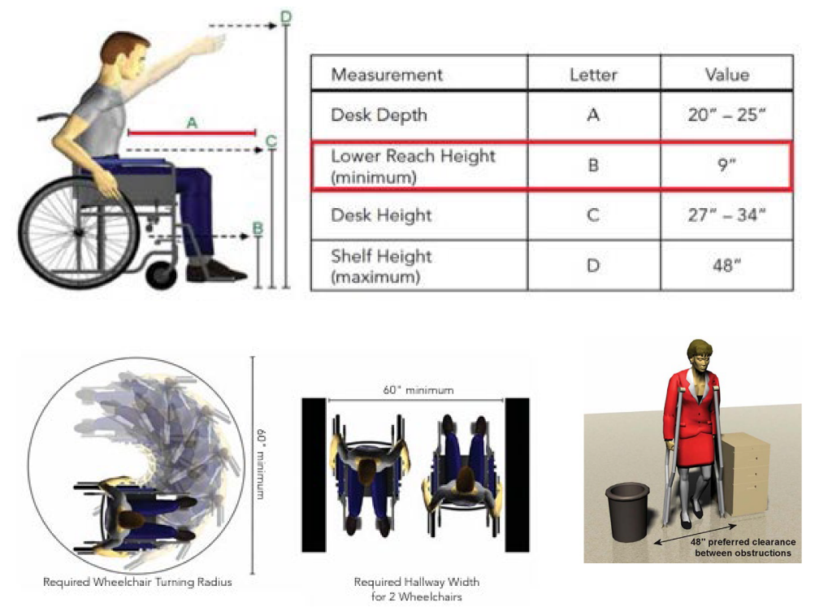
- Wheelchair dimension requirement for elderly
Source: Choueiri et al. [24]

G. Challenges that the elderly may face in their living spaces

The era of smart buildings has come a long way since it was founded in the 1980s, following the advancement of technology and the shift in priorities within society [25]. At first, smart buildings were being referred to as buildings that provide maximum optimization of productivity, cost, and management, but now they take a more holistic approach to design. They do not only focus on intelligence and innovation of technology but also have sustainability principles to minimize the impact of the environment [26].

This in itself is in accordance with the elderly's requirements in their structures, as these can be made use of for different purposes and functions. Also included is smart use of furniture that facilitates proper space for mobility and the use of non-polluting building materials that are not harmful to the environment or the users' health, especially the elderly. Most of the ideas for smart design for the elderly can be adapted. Smart devices can be utilized and operated in such a way that they do not consume extra electricity since they are utilized again and again in the case of medical devices, ventilators, air beds, etc., or consume electricity since the old individuals cannot move much and turn on/off appliances like lights and some other devices. Some of the Key Takeaways for Designers would be as shown in Figure 4:
- Prevent falls (lighting, grab bars, clear floors).
- Enable senses (contrast, acoustics, tactile signals).
- Enable independence (voice operation, convenient storage).
- Reduce stress (relaxed hues, natural light, quiet zones).
- Sustaining indoor environmental quality (appropriate lighting, new ventilation, reducing emissions, providing thermal comfort, and achieving visual comfort)
- Reducing costs and expenses (using smart devices and other appliances, provided they are energy- and water-efficient, and using smart management systems that control the operation of systems in accordance with their needs)
- Adopting sustainability in interior design) Material selection, energy efficiency, water conservation, biophilic design, waste management, multi-functional spaces, green certifications, durability, and smart furniture.

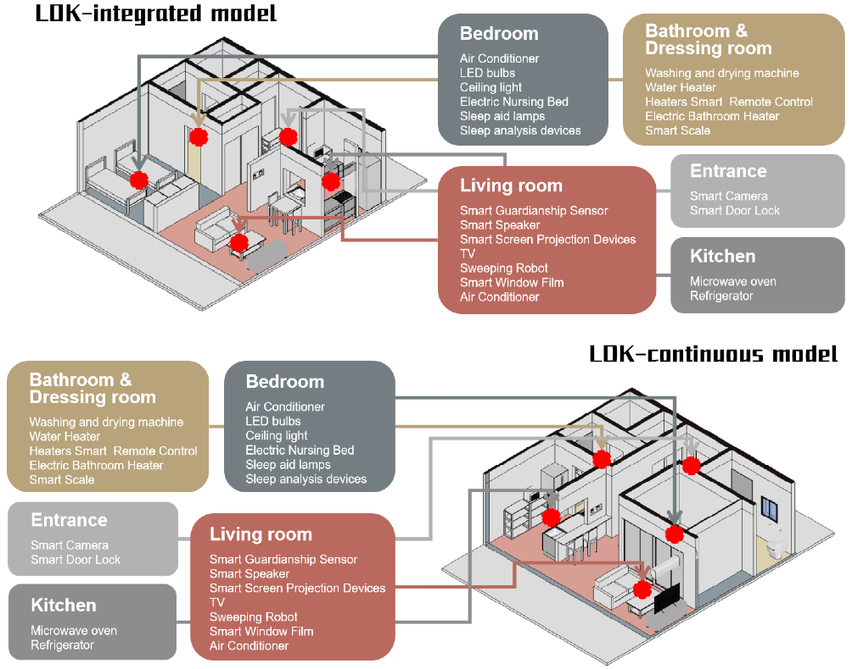
- Smart home model templates and smart device layout guides
Source: Teng et al. [27]

H. New technologies for assisting the elderly based on Artificial Intelligence (AI)

The intelligent technological devices that help to eliminate the loneliness experienced by elderly people in that they can help them in their daily lives but not fully displacing the direct interventions and need human assistance to help them interact [28]. The variables in the determination of the effectiveness of assistive technologies are the perceptions which the older ones have of same, acceptability, and even readiness to use assistive technologies. Perception of caregivers and healthcare professionals is also relevant, as well as acceptability socio-cultural dimension.
Innovation of the Smart Home and Ambient Assisted Living (AAL) system, combined with AI, is a powerful step in enabling better care of the elderly, neutralizing social isolation [29]. Such smart living conditions offer such services as constant surveillance, guidance, and medical healing support, which raises the level of care availability and reduces medical mistakes [29]. Smart Homes may recognize and monitor chronic pain [30]. Forestall domestic accidents by means of fall destination and appliance-controlling AI [31]. Improve the cognitive skills with the help of smart speakers and programs such as Metamemory exercises [32]. The possible additional safety is provided by AI and Computer Vision practices, which first utilize less privacy-invasive approaches, including transfer learning and deep learning, to identify critical conditions and send the necessary warnings to their safety contacts [33].
Although the (AAL) designs focus on ensuring that the user does not lose their autonomy and has the freedom to respect ethical principles, the elderly people have been found to have limited knowledge about the technologies and prefer a human-augmented level of assistance over a human-replaced one [34]. The demonstrated positivity in quality-of-life enhancement and the ability of independent aging cannot go unopposed, and the difficulties of the application concerning privacy policies, data security measures, and digital literacy are still to be resolved to expand the utilization of this technology [35], [36].

H.1. New technologies for assisting the elderly based on Artificial Intelligence (AI)

The availability of technological innovations, especially in terms of mobile digital technologies and Artificial Intelligence (AI), is already helping the elderly to live and manage their health. Such innovations provide essential tele-assistance such as diagnosis of the disease, adherence to the medication (with MEDSReM 91.0%, hypertensive medicines reported adherence increased by 18.5%), activity monitoring, fall detection, emergency calls, and overcoming loneliness [37], [38]. Such projects as the European Horizon2020 Move Care platform include smart devices, home automation, and virtual caregivers to offer an individualized vision on frailty monitoring [39]. Activity of daily living (ADL) is monitored with wearable sensors, wireless sensors, cameras, and computer vision powered by an AI [40]. However, there is a question of data security and trust. Technologies (AT) are also very efficient in the areas of mobility, illness treatment, and sensorial assistance, and apps are especially well in the personal control of health as shown in Figure 5 [41].

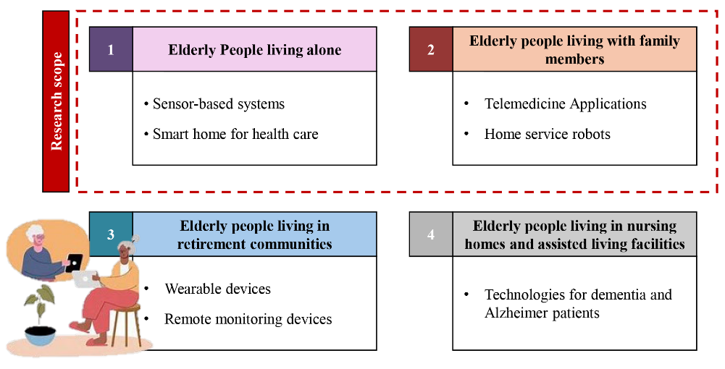
- Technologies for older people in different living situations
Source: Researchers

- AR and VR are gaining popularity in the areas of promoting the lives and wellbeing of the elderly. Some articles show the benefits of VR in elderly peoples include its utility, user comfort, and entertainment in personal assistance, virtual assistants, and exergames [42], [43]. The Assistive VR Gym is an example of a project that enables interacting with virtual robots to enhance rehabilitation [44]. The intelligent assistive systems that seamlessly merge AR and serious games may serve as evidence of the future adaptive decision-making [45]. VR is effective in mitigating the risks of social isolation because it can provide exciting social events (e.g. virtual cycling experiences) even to the so-called oldest old (De Immersive VR can also lessen anxiety among the residents of care homes with only a few side effects and contribute to the physical activity, which is also a positive aspect of general well-being [46], [47]. Also, the recent experience of the VR-based reminiscence therapy has proven its effectiveness in enhancing cognitive functions, specifically, memory, which is higher than when dealing with conventional procedures [48].
- AR supports the digital accessibility of the elderly, but in order to have a successful analog treatment, inclusive design is paramount [49]. With such factors such as prior knowledge of technology and psychomotor skills playing a big role in the enjoyment levels, it is apparent that user training and designing to make products user friendly are required to break the barrier [50]. Emotional effects of immersive VR should also be thoroughly considered since it usually causes vast emotions and can create a gap between the reality and the user [51]. Nevertheless, the level of reliability and cooperation between the researchers, developers, and healthcare professionals is very crucial to effective and ethical VR/AR solution despite these difficulties [52].

H.2. Robotics in Elderly Healthcare: Enabling Independence and Quality of Life

- Helping Robots

Using such sensor and actuator-equipped robotic systems, physical support can be offered to elderly peoples in terms of mobility, personal hygiene, and household duties. Such robots would apply the programming to adjust to personal requirements that would be responsive and personalized care [9]. Robot exoskeletons and mobility devices allow elderly people with walking limitations to become independent and do what they normally would not. Mind robots are developed to assist the older patients in hospitals in their treatment. These robots have the ability of influencing the emotional, physical, and social well-being of the humans by merely contacting them physical. This added element was observed to boost the spirits of elderly peoples.

- Social robots

Social interaction plays a crucial role in overcoming social isolation and increasing the mental well-being of elderly peoples. Social robots help in companionship and interaction which grants emotional support and stimulates the mind [53]. These robots are designed to chat, play games, and even make old-timers go through reminiscent therapy as their quality of life is enhanced on a bigger scale. The physical appearance of the robot has much to do with the acceptability of the same among elderly people. Upon providing robotic companion animals to dementia stricken elderly people, it was found that there were positive results. Research indicates that for the aged with dementia, companion robots in terms of size, weight and shape are able to stimulate their brains [54]. Figure 6 shows the elderly’s specific needs and the solution by smart interior design elements.

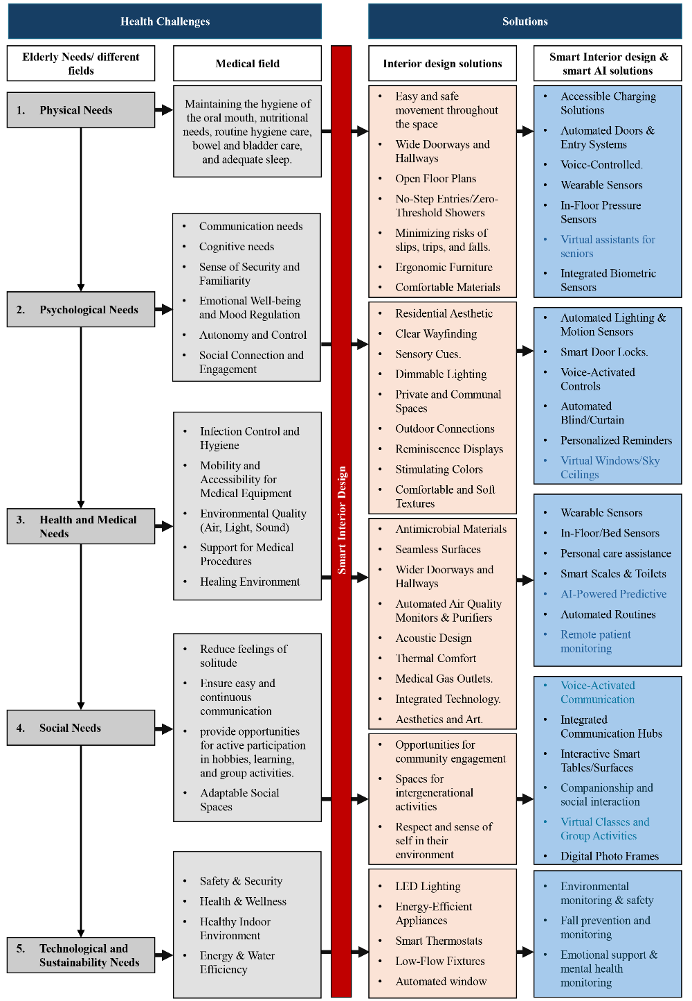
- The elderly’s specific needs and the solution by smart interior design elements
Source: Researchers

I. Disadvantage of AI for elderly

There are also certain disadvantages associated with artificial intelligence, which on the other hand can be used to draw adverse directions. The following are some of the probable flaws in the part of AI in the elderly [55]:
- Poor context and emotional knowledge
- The AI systems might not gather the emotional or contextual elements behind the speech of the seniors, hence cannot respond appropriately and offer care. In addition, the AI devices can be too generic and fail to support individual needs of the older population.
- Technological barriers
- Not all the seniors might be conversant with technology use and therefore might not have access and dramatically utilize AI-based systems.
- Privacy Concerns
- Cases where AI systems gather, save and analyze huge blocks of personal data are also common, which puts data protection and security into question, especially in vulnerable individuals like seniors who can easily become the target of identity thieves or fraudsters.
- Cost
- Micros could be costly to acquire and maintain and hence not affordable to the frail elderly with fixed incomes or have limited funds.
- Dependency
- The elderly might end up being too dependent on the AI systems to help them and this might cause them to lose some form of independence and do their daily activities without the help of technology.
- Human Interaction
- It will never be possible to substitute human contact with AI systems, and elderly people can feel even more isolated when using technology as the only source of companionship and communication.

Figure 7 shows the smart interior design steps that meet the safety and requirements of the elderly, using AI technologies.

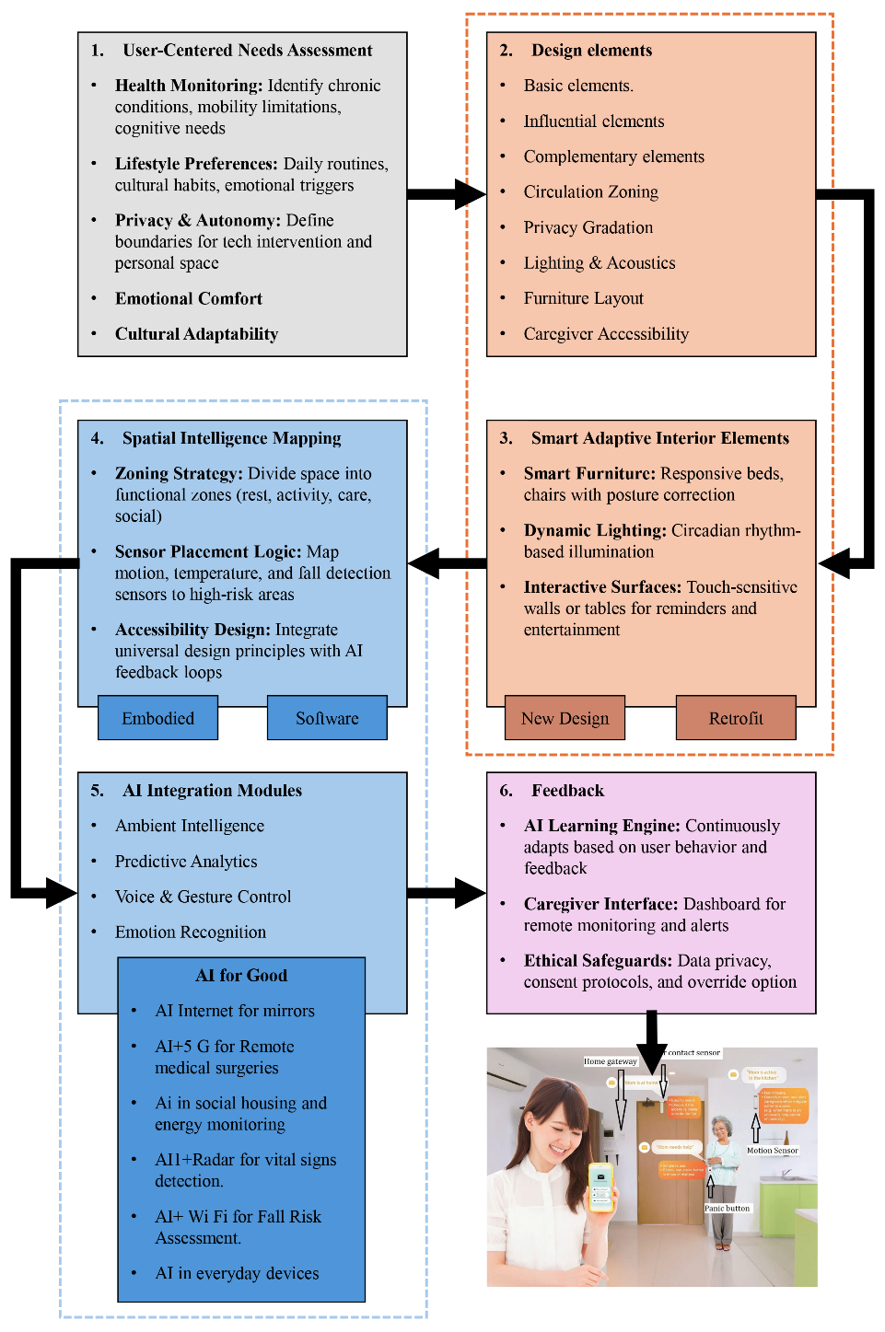
- Smart Interior design steps that meet the safety and requirements of the elderly, using AI technologies
Source: Researchers

III. Results

Three main topics were studied in previous literature: the elderly and their needs, identifying the symptoms of diseases they suffer from, and their needs to overcome their weakness or inability to lead normal lives. The elements of interior design and smart interior design were also studied, translating these needs into architectural solutions for interior design for the elderly.

Solutions were also proposed that integrate the use of artificial intelligence after studying the programs or automated services it can provide that can monitor, analyze, and assist the elderly in their daily lives, health, and routine. The research developed a methodology and framework that explores how to use artificial intelligence to meet the needs of the elderly in the smart interior design of their buildings, particularly their homes.

Figure 8 shows the Relation between the three main elements in the methodology of the research and the responsible major fields. Furthermore, Table I shows a framework of using artificial intelligence to meet the needs of the elderly in smart interior design. Figure 9 shows the potential of using AI in design which help elderly to imagine their spaces.

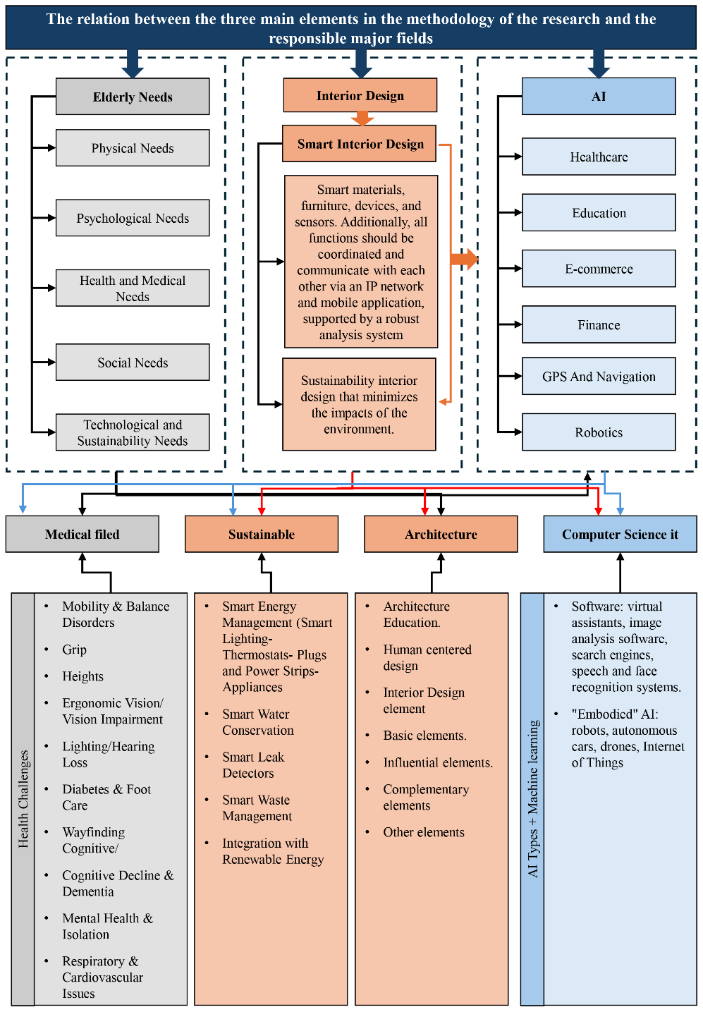
- The relation between the three main elements in the methodology of the research and the responsible major fields
Source: Researchers

- Framework of using artificial intelligence to meet the needs of the elderly in smart interior design. Source: Researchers

 |  | Smart Interior design elements that meet the safety and requirements of the elderly Using AI technologies
 |  | Basic Elements |  |  |  | Architecture elements |  |  | Influenced elements |  |  |  | AI
Knowing the medical condition of the elderly |  | Floor | Ceiling | Walls | Furniture | Stairs | Openings |  | Lighting | Color | Ventilation | Sound iso. | Software | Embodied AI
 |  |  |  |  |  |  | Doors | Windows |  |  |  |  | Virtual assistants, image analysis software, search engines, and speech and face recognition systems. | Robots, autonomous cars, drones, Internet of Things
Health Challenges | Mobility & Balance Disorders | • |  | • | • | • |  |  |  |  |  |  | Automated Doors & Entry Systems.  Voice-Controlled.  Wearable Sensors.  Integrated Biometric Sensors.  Accessible Charging Solutions | Virtual assistants for seniors.  Fall prevention and monitoring
Health Challenges | Grip | • |  |  | • | • | • | • | • | • | • |  | Automated Blind/Curtain.  Smart Door Locks.  Automated Lighting & Motion Sensors. | Robots, Virtual assistants for seniors.  Virtual Windows/Sky Ceilings.  Interactive Smart Tables/Surfaces
Health Challenges | Heights |  |  | • | • |  | • | • | • |  |  |  | Smart Scales & Toilets | Automated Blind/Curtain
Health Challenges | Ergonomic Vision/ Vision Impairment |  |  |  | • |  |  |  | • | • |  |  | Smart Scales & Toilets | Interactive Smart Tables/Surfaces
Health Challenges | Lighting | • | • | • |  | • |  |  | • |  |  |  | Voice-Activated Controls  Automated Lighting & Motion Sensors  Sensory Cues. | Voice-Activated Communication
Health Challenges | Hearing Loss |  |  |  |  |  |  |  |  |  |  | • | Virtual assistants, image analysis software, search engines, | Robots, Virtual assistants for seniors.  Virtual Windows/Sky Ceilings.
Health Challenges | Diabetes & Foot Care | • |  | • | • | • | • | • | • |  |  |  | Automated Doors & Entry Systems.  Voice-Controlled.  Wearable Sensors. Integrated Biometric Sensors.  Accessible Charging Solutions | Virtual assistants for seniors  Fall prevention and monitoring.
Health Challenges | Wayfinding Cognitive/  Cognitive Decline & Dementia |  |  | • | • |  | • |  |  | • |  |  | Secure exits (hidden locks, GPS tracking wearables. | Virtual assistants, image analysis software, search engines, and speech and face recognition systems
Health Challenges | Mental Health & Isolation |  |  |  | • |  |  |  |  | • | • | • | Tech for connection (tablet stands for video calls). | Emotional support & mental health monitoring
Health Challenges | Respiratory & Cardiovascular Issues |  |  |  | • | • |  | • |  |  | • |  | Temperature control (smart thermostats to prevent extremes) | Fall prevention and monitoring
Physical Needs. | Maintaining the hygiene of the oral mouth, nutritional needs, routine hygiene care, bowel and bladder care, and adequate sleep. | • | • | • | • |  |  | • | • |  | • | • | Antimicrobial Materials  Seamless Surfaces | Fall prevention and monitoring
Psychological Needs | Communication needs | • |  |  | • |  |  | • |  |  |  |  | Integrated Communication Hubs | Voice-Activated Communication  Virtual Classes and Group Activities
Psychological Needs | Cognitive needs |  |  |  | • |  |  | • |  |  |  |  | Virtual assistants, image analysis software, search engines, and speech and face recognition systems | Virtual assistants, image analysis software, search engines, and speech and face recognition systems
Psychological Needs | Sense of Security and Familiarity. |  |  |  |  |  | • |  | • | • |  |  | Automated Doors & Entry Systems  Accessible Charging Solutions | Environmental monitoring & safety  Fall prevention and monitoring.
Psychological Needs | Emotional Well-being and Mood Regulation. | • | • |  | • |  |  | • | • | • | • |  | Interactive Smart Tables/Surfaces | Emotional support & mental health monitoring
Psychological Needs | Autonomy and Control. |  |  |  | • |  | • | • | • | • |  |  | Emotional support & mental health monitoring | Environmental monitoring & safety  Fall prevention and monitoring
Psychological Needs | Social Connection and Engagement. |  |  |  | • |  |  | • |  |  |  |  | Virtual assistants, image analysis software, search engines, and speech and face recognition systems | Voice-Activated Communication  Virtual Classes and Group Activities
Health and Medical Needs | Infection Control and Hygiene. | • |  | • | • | • | • | • |  |  | • |  | In-Floor/Bed Sensors  Wearable Sensors | Remote patient monitoring.
Health and Medical Needs | Mobility and Accessibility for Medical Equipment. | • |  | • | • | • | • | • | • |  |  |  | In-Floor/Bed Sensors  Wearable Sensors | AI-Powered Predictive.
Health and Medical Needs | Environmental Quality (Air, Light, Sound). | • | • | • | • | • | • | • | • | • | • | • | Wearable Sensors In-Floor/Bed Sensors  LED Lighting  Energy-Efficient Appliances  Smart Thermostats  Low-Flow Fixtures  Automated window | Remote patient monitoring.
Health and Medical Needs | Support for Medical Procedures. | • | • | • | • | • | • | • | • | • | • | • | Acoustic Design  Thermal Comfort  Medical Gas Outlets.  Integrated Technology | Remote patient monitoring.  AI-Powered Predictive.
Health and Medical Needs | Healing Environment. | • | • | • | • | • | • | • | • | • | • | • | Wearable Sensors  In-Floor/Bed Sensors  Acoustic Design  Thermal Comfort  Medical Gas Outlets.  Integrated Technology | Remote patient monitoring.  AI-Powered Predictive.
Social Needs. | Reduce feelings of solitude | • | • | • | • |  |  | • | • | • | • | • |  | Virtual Classes and Group Activities.
Social Needs. | Ensure easy and continuous communication | • | • | • | • |  |  | • | • | • | • | • | Integrated Communication Hubs | Voice-Activated Communication  Virtual Classes and Group Activities
Social Needs. | Provide opportunities for active participation in hobbies, learning, and group activities. | • | • | • | • |  |  | • | • | • | • | • | Integrated Communication Hubs | Voice-Activated Communication  Virtual Classes and Group Activities
Social Needs. | Adaptable Social Spaces | • |  | • | • |  |  | • |  |  | • |  | Virtual assistants, image analysis software, search engines, and speech and face recognition systems | Virtual Classes and Group Activity
Technological and Sustainability Needs. | Safety & Security |  |  |  |  | • | • | • | • |  |  | • | Automated Doors & Entry Systems  Accessible Charging Solutions | Environmental monitoring & safety  Fall prevention and monitoring.
Technological and Sustainability Needs. | Health & Wellness | • |  | • | • | • | • | • | • | • | • | • | Antimicrobial Materials  Seamless Surfaces  Wider Doorways and Hallways  Automated Air Quality Monitors & Purifiers  Acoustic Design  Thermal Comfort  Medical Gas Outlets.  Integrated Technology.  Aesthetics and Art. | Fall prevention and monitoring  \  Environmental monitoring & safety
Technological and Sustainability Needs. | Healthy Indoor Environment | • | • | • | • | • | • | • | • | • | • | • | Open Floor Plans  No-Step Entries/Zero-Threshold Showers  Minimizing risks of slips, trips, and falls.  Ergonomic Furniture | AI-Powered Predictive  Environmental monitoring & safety
Technological and Sustainability Needs. | Energy & Water Efficiency | • | • | • | • |  | • | • | • |  | • | • | LED Lighting  Energy-Efficient Appliances  Smart Thermostats  Low-Flow Fixtures  Automated window | Environmental monitoring & safety

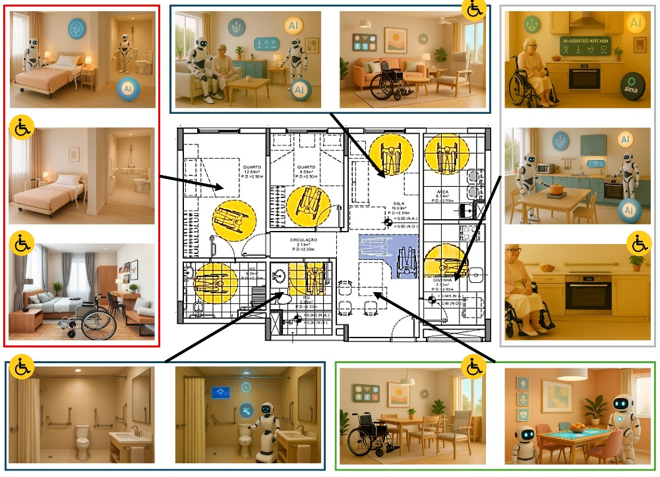

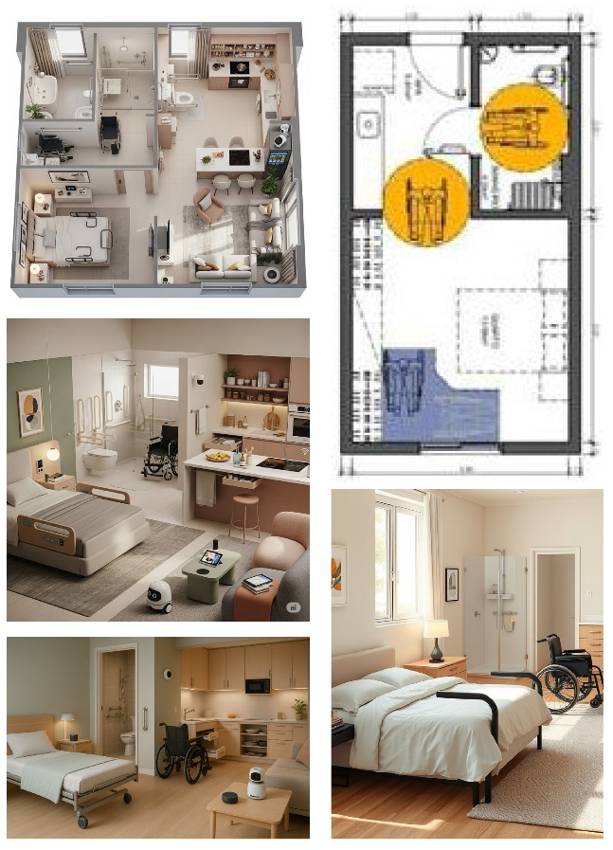

- Using AI to generate image which help elderly to imagine their spaces
Source: Researchers

IV. Conclusion

This study has shed some light on the multidimensionality of the elderly needs as well as the paramount importance of interpreting the needs into responsive and versatile interior designing. Through the integration of the results of researches into age-related issues, symptomatic of diseases and space restrictions, the research highlights the need to incorporate human-centered design into facilities that not only accommodate physical weaknesses but also provide emotional security and self-sufficiency.
Furthermore, the implementation of artificial intelligence in smart interior spaces is life changing. AI technologies may proactively help the elderly in their daily activities, treatment and improvement of their health conditions in addition to increasing safety in their households through their monitoring, analysis and customized help. The given framework offers an extensive approach that interpolates between architecture design and intelligent systems and leads to the introduction of empathetic, efficient, and future-proof interior spaces.
In conclusion, the study can be used to bring further insight into how the future smart interior architecture guided by the specifics of aging people and enabled through the power of AI can transform the domestic environment into the supportive ecosystem that will empower people with a sense of dignity, independence, and a better quality of life.

V. Recommendations

Egypt is the focus of this research, and we recommend further research to provide useful suggestions for creating supportive living spaces around the world that keep pace with technological advances, so that older adults can age safely and comfortably in their homes and communities. Developers of software and devices that support the elderly and incorporate AI technology should also ensure that the software interface is easy to use and that data is kept confidential and difficult to hack.

References

[1] University of Washington, “Institute of Health Metrics and Evaluation. Global Health Data Exchange (GHDx).,” Http://Ghdx.Healthdata.Org/Gbd-Results-Tool?Params=Gbd-Api-2019-Permalink/D780Dffbe8a381B25E1416884959E88B, no. May, 2019.
[2] World Health Organization, “Why Population Ageing Matters to Health: A Global Perspective,” 2011.
[3] R. H. Teo, W. H. Cheng, L. J. Cheng, Y. Lau, and S. T. Lau, “Global prevalence of social isolation among community-dwelling older adults: A systematic review and meta-analysis,” 2023. doi: 10.1016/j.archger.2022.104904.
[4] Y. Yon, C. R. Mikton, Z. D. Gassoumis, and K. H. Wilber, “Elder abuse prevalence in community settings: a systematic review and meta-analysis,” Lancet Glob Health, vol. 5, no. 2, 2017, doi: 10.1016/S2214-109X(17)30006-2.
[5] F. Chaibm, “WHO launches digital app to improve care for older people.” Accessed: May 14, 2025. [Online]. Available: https://www.who.int/news/item/30-09-2019-who-launches-digital-app-to-improve-care-for-older-people
[6] A. Aly, H. Dessoki, A. Eldeeb, and A. Mohamed, “Challenges being Faced by the Elderly People in Accessing Health Services in Beni-Suef University Hospital,” NILES journal for Geriatric and Gerontology, vol. 4, no. 2, 2021, doi: 10.21608/niles.2021.191208.
[7] M. A. Farage, K. W. Miller, F. Ajayi, and D. Hutchins, “Design principles to accommodate older adults.,” 2012. doi: 10.5539/gjhs.v4n2p2.
[8] I. M. Obeidat and S. M. Obeidat, “Designing for the Elderly : Comfort, Health and Well-Being,” International Design Journal, vol. 6, no. 1, 2016, doi: 10.12816/0036457.
[9] Government Office for Science, “Future of an Ageing Population,” 2016. Accessed: Jun. 05, 2025. [Online]. Available: https://assets.publishing.service.gov.uk/media/5d273adce5274a5862768ff9/future-of-an-ageing-population.pdf
[10] K. Connellan, M. Gaardboe, D. Riggs, C. Due, A. Reinschmidt, and L. Mustillo, “Stressed spaces: Mental health and architecture,” Health Environments Research and Design Journal, vol. 6, no. 4, 2013, doi: 10.1177/193758671300600408.
[11] M. R. Rose et al., “What is aging?,” 2012. doi: 10.3389/fgene.2012.00134.
[12] M. M. Daud, F. M. Ali, and W. M. D. W. Zaki, “A REVIEW ON SMART HOME DESIGN AND TECHNOLOGY FOR ELDERLY,” JOURNAL INFORMATION AND TECHNOLOGY MANAGEMENT (JISTM), vol. 9, no. 37, pp. 77–85, Dec. 2024, doi: 10.35631/JISTM.937006.
[13] Y. Hou and B. Li, “Research on Intelligent Interior Space Design under Home Care Mode,” Journal of Intelligence and Knowledge Engineering, vol. 2, no. 2, pp. 66–70, Jun. 2024, doi: 10.62517/JIKE.202404212.
[14] Q. Shu and H. Liu, “Application of Artificial Intelligence Computing in the Universal Design of Aging and Healthy Housing,” Comput Intell Neurosci, vol. 2022, 2022, doi: 10.1155/2022/4576397.
[15] Y. Zhao, “Research on the matching between the psychological needs of the elderly and the interior design of intelligent elderly care,” Journal of Education, Humanities and Social Sciences, vol. 28, pp. 894–899, Apr. 2024, doi: 10.54097/8HSVJM72.
[16] F. Wang, Y. Qi, and J. Liu, “Innovative research on the design of aging-friendly interior space in the context of computer simulation,” Applied Mathematics and Nonlinear Sciences, vol. 9, no. 1, 2024, doi: 10.2478/amns.2023.2.00870.
[17] C. Zhou, Y. Dai, T. Huang, H. Zhao, and J. Kaner, “An Empirical Study on the Influence of Smart Home Interface Design on the Interaction Performance of the Elderly,” Int J Environ Res Public Health, vol. 19, no. 15, 2022, doi: 10.3390/ijerph19159105.
[18] B. Liu and C. Wang, “Elderly-Centric Chromatics: Unraveling the Color Preferences and Visual Needs of the Elderly in Smart APP Interfaces,” Int J Hum Comput Interact, vol. 41, no. 5, pp. 3527–3536, 2025, doi: 10.1080/10447318.2024.2338659;WGROUP:STRING:PUBLICATION.
[19] A. Ghorayeb, R. Comber, and R. Gooberman-Hill, “Development of a Smart Home Interface With Older Adults: Multi-Method Co-Design Study,” JMIR Aging, vol. 6, 2023, doi: 10.2196/44439.
[20] J. C. Briede-Westermeyer, P. G. Radici Fraga, M. J. Schilling-Norman, and C. Pérez-Villalobos, “Identifying the Needs of Older Adults Associated with Daily Activities: A Qualitative Study,” Int J Environ Res Public Health, vol. 20, no. 5, 2023, doi: 10.3390/ijerph20054257.
[21] I. Koutani, “ Overcoming the barriers that elderly face in their local environment,” Stockholm, Sweden, 2019. Accessed: Jun. 05, 2025. [Online]. Available: https://www.diva-portal.org/smash/get/diva2:1356603/FULLTEXT01.pdf
[22] D. Maalej Bouricha and D. Maalej Kammoun, “Upgrading the living Space of the elderly person: towards a healthcare design,” Journal of Salutogenic Architecture, vol. 2, no. 1, 2023, doi: 10.38027/jsalutogenic_vol2no1_6.
[23] S. Tomsone, L. Saukuma, Z. Liepina, and J. Zalkalns, “ Accessibility problems in home environment for seniors in Latvia: Experience from the research project innov Age (WP2) ,” SHS Web of Conferences, vol. 40, 2018, doi: 10.1051/shsconf/20184003004.
[24] M. Choueiri et al., “Can interactive systems be designed for conviviality? A case study,” in DIS 2018 - Companion Publication of the 2018 Designing Interactive Systems Conference, 2018. doi: 10.1145/3197391.3205437.
[25] A. Singh, “What Are Smart Buildings?” Accessed: Jul. 30, 2025. [Online]. Available: https://www.azobuild.com/article.aspx?ArticleID=8726
[26] “A Timeline in the History of Smart Buildings - Hereworks.” Accessed: Jul. 30, 2025. [Online]. Available: https://hereworks.io/tech-talk/a-timeline-in-the-history-of-smart-buildings/
[27] X. Teng, Z. Shen, and Y. Zhang, “Design Guidelines for Smart Nursing Homes in the Context of Aging,” Buildings 2025, Vol. 15, Page 1516, vol. 15, no. 9, p. 1516, May 2025, doi: 10.3390/BUILDINGS15091516.
[28] Y. Yang, C. Wang, X. Xiang, and R. An, “AI Applications to Reduce Loneliness Among Older Adults: A Systematic Review of Effectiveness and Technologies,” Healthcare 2025, Vol. 13, Page 446, vol. 13, no. 5, p. 446, Feb. 2025, doi: 10.3390/HEALTHCARE13050446.
[29] D. Marikyan, S. Papagiannidis, and E. Alamanos, “A systematic review of the smart home literature: A user perspective,” Technol Forecast Soc Change, vol. 138, 2019, doi: 10.1016/j.techfore.2018.08.015.
[30] R. L. Fritz, M. Wilson, G. Dermody, M. Schmitter-Edgecombe, and D. J. Cook, “Automated smart home assessment to support pain management: multiple methods analysis,” J Med Internet Res, vol. 22, no. 11, 2020, doi: 10.2196/23943.
[31] M. Costanzo, R. Smeriglio, and S. Di Nuovo, “New technologies and assistive robotics for elderly: A review on psychological variables,” Archives of Gerontology and Geriatrics Plus, vol. 1, no. 4, p. 100056, Dec. 2024, doi: 10.1016/J.AGGP.2024.100056.
[32] J. Kim et al., “Efficacy of smart speaker-based metamemory training in older adults: Case-control cohort study,” J Med Internet Res, vol. 23, no. 2, 2021, doi: 10.2196/20177.
[33] A. S. Somanathan, “To What Extent Can Transcatheter Devices Replace Open-Heart Surgery in the Treatment of Cardiac Septal Defects?,” World J Cardiovasc Surg, vol. 12, no. 10, 2022, doi: 10.4236/wjcs.2022.1210024.
[34] L. Burzagli and P. L. Emiliani, “A study of the role of AI to favor the well-being of people in smart cities,” Journal of Smart Cities and Society, Jul. 2025, doi: 10.1177/27723577251357794.
[35] Liyakathunisa, A. Alsaeedi, S. Jabeen, and H. Kolivand, “Ambient assisted living framework for elderly care using Internet of medical things, smart sensors, and GRU deep learning techniques,” J Ambient Intell Smart Environ, vol. 14, no. 1, 2022, doi: 10.3233/AIS-210162.
[36] “Understanding Artificial Intelligence and Its Impact on Seniors - SDN.” Accessed: Jul. 30, 2025. [Online]. Available: https://seniordailynews.net/understanding-artificial-intelligence-and-its-impact-on-seniors/
[37] M. Weck and M. Afanassieva, “Toward the adoption of digital assistive technology: Factors affecting older people’s initial trust formation,” Telecomm Policy, vol. 47, no. 2, 2023, doi: 10.1016/j.telpol.2022.102483.
[38] M. Costanzo, R. Smeriglio, and S. Di Nuovo, “New technologies and assistive robotics for elderly: A review on psychological variables,” Archives of Gerontology and Geriatrics Plus, vol. 1, no. 4, p. 100056, Dec. 2024, doi: 10.1016/J.AGGP.2024.100056.
[39] M. Luperto et al., “A Multi-Actor Framework Centered around an Assistive Mobile Robot for Elderly People Living Alone,” in IEEE/RSJ International Conference on Intelligent Robots and Systems (IROS 2018): Workshop on Robots for Assisted Living, 2018.
[40] J. Wu, Y. Feng, and P. Sun, “Sensor fusion for recognition of activities of daily living,” Sensors (Switzerland), vol. 18, no. 11, 2018, doi: 10.3390/s18114029.
[41] I. Keshta and A. Odeh, “Security and privacy of electronic health records: Concerns and challenges,” 2021. doi: 10.1016/j.eij.2020.07.003.
[42] H. R. Marston and J. Samuels, “A review of age friendly virtual assistive technologies and their effect on daily living for carers and dependent adults,” 2019. doi: 10.3390/healthcare7010049.
[43] S. Syed-Abdul et al., “Virtual reality among the elderly: A usefulness and acceptance study from Taiwan,” BMC Geriatr, vol. 19, no. 1, 2019, doi: 10.1186/s12877-019-1218-8.
[44] Z. Erickson, Y. Gu, and C. C. Kemp, “Assistive VR Gym: Interactions with Real People to Improve Virtual Assistive Robots,” in 29th IEEE International Conference on Robot and Human Interactive Communication, RO-MAN 2020, 2020. doi: 10.1109/RO-MAN47096.2020.9223609.
[45] F. Ghorbani, M. Farshi Taghavi, and M. Delrobaei, “Towards an intelligent assistive system based on augmented reality and serious games,” Entertain Comput, vol. 40, 2022, doi: 10.1016/j.entcom.2021.100458.
[46] H. Rmadi et al., “Tolerance of immersive head-mounted virtual reality among older nursing home residents,” Front Public Health, vol. 11, 2023, doi: 10.3389/fpubh.2023.1163484.
[47] M. Gabbi, V. Villani, and L. Sabattini, “Towards Mixed Reality Applications to Support Active and Lively Ageing,” Springer Proceedings in Advanced Robotics, vol. 33 SPAR, pp. 107–111, 2024, doi: 10.1007/978-3-031-76428-8_21/FIGURES/1.
[48] N. Khirallah Abd El Fatah, M. Abdelwahab Khedr, M. Alshammari, and S. Mabrouk Abdelaziz Elgarhy, “Effect of Immersive Virtual Reality Reminiscence versus Traditional Reminiscence Therapy on Cognitive Function and Psychological Well-being among Older Adults in Assisted Living Facilities: A randomized controlled trial,” Geriatr Nurs (Minneap), vol. 55, 2024, doi: 10.1016/j.gerinurse.2023.11.010.
[49] X. Jin et al., “Exploring the Opportunity of Augmented Reality (AR) in Supporting Older Adults Explore and Learn Smartphone Applications,” Conference on Human Factors in Computing Systems - Proceedings, May 2024, doi: 10.1145/3613904.3641901/SUPPL_FILE/3613904.3641901-TALK-VIDEO.VTT.
[50] H. Bradwell et al., “Implementation of Virtual Reality Motivated Physical Activity via Omnidirectional Treadmill in a Supported Living Facility for Older Adults: A Mixed-Methods Evaluation.: Virtual reality to motivate physical activity for older adults,” Conference on Human Factors in Computing Systems - Proceedings, May 2024, doi: 10.1145/3613904.3642281/SUPPL_FILE/PN9304-SUPPLEMENTAL-MATERIAL-2.PDF.
[51] A. Ramalho, P. Duarte-Mendes, R. Paulo, J. Serrano, and J. Petrica, “Crossing the digital frontier: are older adults ready for virtual reality workouts?,” Front Public Health, vol. 12, 2024, doi: 10.3389/fpubh.2024.1324004.
[52] S. Abdi, L. De Witte, and M. Hawley, “Exploring the potential of emerging technologies to meet the care and support needs of older people: A delphi survey,” Geriatrics (Switzerland), vol. 6, no. 1, 2021, doi: 10.3390/geriatrics6010019.
[53] S. Padhan, A. Mohapatra, S. K. Ramasamy, and S. Agrawal, “Artificial Intelligence (AI) and Robotics in Elderly Healthcare: Enabling Independence and Quality of Life,” Cureus, 2023, doi: 10.7759/cureus.42905.
[54] M. Costanzo, R. Smeriglio, and S. Di Nuovo, “New technologies and assistive robotics for elderly: A review on psychological variables,” Archives of Gerontology and Geriatrics Plus, vol. 1, no. 4, p. 100056, Dec. 2024, doi: 10.1016/J.AGGP.2024.100056.
[55] “AI for seniors: benefits and drawbacks - BoomersHub Blog.” Accessed: Jul. 30, 2025. [Online]. Available: https://www.boomershub.com/blog/ai-for-seniors-does-it-enhance-or-impair-quality-of-life

Authors and Affiliations

Christine Ezzat Danial
Department of Architecture, Faculty of Engineering, El Shorouk Academy, El Shorouk City, Egypt
E-mail: christineezzat@rocketmail.com ; k.ezzat@sha.edu.eg
ORCID: 0000-0002-4778-0126

Girges Sidhom
Department of Architecture, Faculty of Engineering, Cairo University, Cairo, Egypt
E-mail: girges.sidhom@outlook.com
ORCID: 0009-0009-3499-9135

