Risk Assessment of schedule for Solar Energy Projects in Egypt
Sarah Saeed Reyad ¹, Mohamed Ali Nower ²
¹ Lecturer in Civil Engineering Department, The Higher Institute of Engineering, El Shorouk Academy, Cairo, Egypt, s.reyad@sha.edu.eg
² Researcher at Water management research institute, National Water research Center, Cairo, Egypt, Nower2020@gmail.com
ABSTRACT
Solar energy projects are a clean and renewable source of electrical energy. Risk assessment of schedule for solar energy projects provides an improved decision-making process to meet the project’s deadline, taking into consideration every potential risk. This research aims to assess the risks of schedule for solar energy projects in Egypt. It was a result of brainstorming sessions and questionnaires made by experts, in addition to using Primavera software for risk analyzing, processing acquired data from experts, quantitative and qualitative analysis of data and risk assessment. This research study begins with the definition of risk, identifying probability, severity of impact and analysis. As a result of the proposed risk assessment methodology, the research prioritizes those risks according to their criticality. This research also reinforces the reference to the state's interest in risk management studies and applications for solar energy projects in Egypt, and the results highlighted the importance of managing the risks of these projects. These findings can be applied to solar and renewable energy projects such as wind projects. Also, the research methodology can be applied to any risk management process in construction, industry, research or other projects.
KEYWORDS: Risk management, solar energy, threats, schedule risks, solar energy projects, Photovoltaics, solar ponds, solar panels, renewable energy.
- INTRODUCTION
The expansion of industries and growing population has increased the demand for energy [1] [2]. the world is rushing toward clean energy resources to cope with energy demands [3]. It is necessary for the sustainable development platform to include solar energy initiatives in order to protect public health, and the most potential unconventional source of energy today is solar electricity. Solar energy can be used in different ways, including solar sinks and photovoltaic applications [1], [2]. Solar energy projects have many benefits like scalability, improving electrical services, and ease of access in isolated areas, in addition to helping in redistributing population across the deserts of the east and west of Egypt [3].
As mentioned in the research introduction, the importance and necessity of solar energy projects today, for using them in different ways.
The of solar projects are deemed vital to their success. Since today's business environment is dynamic, risks change rapidly, affecting the projects schedule and must be followed up at all stages, taking into account the risks that may appear suddenly leading to confusion, delay, project termination, or perhaps total collapse. The problem posed by this research put forward the following questions relating to the schedule of solar energy projects in Egypt:
- What are the potential risks?
- What tools and methods are used to identify risks?
- What are the methods of risk analysis?
- Which risks are prioritized?

  - Methods of research
The research aim can be summarized as follows:
- Identification of risks.
- Explain the technique used in identification of risks.
- Determine risk analysis methods.
design and setting of the study:
Using the case study, the risks of solar projects in Egypt were identified, then prioritized according to their analysis. Some studies show that most organizations do not conduct a risk analysis, for example, only 30% of organizations conduct a risk analysis in their projects. [5] [6]
The importance of the research lies in the use of expert brainstorming techniques, questionnaire, analysis tools, and case study [4].
This research is a result of brainstorming sessions and questionnaires made by experts have experience between 10 and 20 years, in addition to using Primavera software for risk analyzing, processing acquired data from experts, quantitative and qualitative analysis of data and risk assessment.
- Results of research
The results of the prioritization of the five most important risks that have been previously responded to and have an impact on the schedule of solar project due to risk sensitivity: S22 includes the absence of water resources and distance from highways, power networks, transmission and distribution, second S30 includes delays in acquiring the start-up signing contracts according to exchange rate change, inflation and various reasons like government policies changes, regulations, or economic conditions, and the third is for S6, which contains delays in obtaining local approvals from DEWA, the fourth is for S34, which is for silicon rooftop solar panels that cause environmental bottlenecks from air emissions during roof fires and from waste from uncontrolled units, and the fifth is for S7, which concerns delays in procurement of construction license. As for the prioritization of the five most important risks after responding to them later by reducing the average, and accepting the low, the results of the ranking of the five most important risks are: S36 comes in the first place, which is the potential impact of production and waste disposal processes on the environment and human health, and the second is S22, which represents the absence of water resources and distance from highways and networks. The third is S30 which is the delay of works and the delay of signing contracts according to the change of the exchange rate and other variables like government policies changes, regulations, or economic conditions, the fourth is S6 delay in obtaining local approvals, and the fifth is the delay of startup approvals S31.

- Discussion
Creating risk management plan including:
  - Risk Definition
A Risk is a potential positive incident which can have positive consequences (opportunity) or negative consequences (threats) [7]. A system risk is a combination of measuring (probability) associated with the risk (or threats) that can affect that system. Measuring this system's sensitivity to these threats reflects how it can be affected by them [8].
  - Risk Management Definition
Application of skills, knowledge, risk management tools and techniques of the enterprise to reduce and mitigate threats to an acceptable level while maximizing opportunities [9].

  - Identifying Risks
Identify and document all potential risks that can affect the project life cycle [10]. Identifying risks ultimately results in a list of project risks [9].

    - Risk identification tools and techniques (methods)
Including historical information and records, checklists (formats and templates), brainstorming sessions, interviews, and flowcharts [10] include nominal group techniques, Delphi method, SWOT analysis, SOAR (Strengths, Opportunities, and state-effect graphs (Case-effect diagram) [11].

  - Risk Classification
Before starting a qualitative or quantitative analysis, standards must be established and a working knowledge of the mechanisms of these criteria and the extent to which they are applied over time and through other various risks. [12]

  - Risk Analysis and Assessment
Application of tools and techniques to determine which risks are most likely to harm or benefit the project [13], and prioritizing the risks using risk assessment methods such as simulation modeling or machine learning or other methods.

    - Qualitative risk analysis
This analysis aims to describe the qualitative magnitude of the risk, and assess probability and impact using qualitative/linguistic terms (low, high, etc.). Roles and responsibilities. Then, the risks are grouped or classified according to their priority to the project objectives.

    - Quantitative risk analysis
This analysis includes the quantitative description of the risk magnitude. It uses specific numerical values to shows the risk probability and its impact on activities. The initial output of this analysis is a quantitative priority list of project risks [14].

    - Risk response planning
Develop strategies that determine how to deal with and manage risks (in advance or during). Not all risks require a response plan. It can be chosen to live with the outcome of a risky event if it occurs. This task involves determining what action to take to minimize threats to the project in that situation. Take action either: avoid, reduce, share, accept, transfer.

  - Risk monitoring and control
Monitor the evolution of risks as it implements an appropriate response plan for certain risks when they materialize [15]. It also includes evaluating risk response plans once they have been put into effect and making any necessary corrections. Ensure that appropriate risk management procedures are followed. Track and monitor identified risks, respond to them, deal with them as they occur, and identify and plan for new risks (with appropriate updates in accordance with emerging risks and policies for dealing with them [9].
  - Risk Audit and Review
Conduct a risk audit such as documenting lessons learned after project completion [16].

  - Advantages of Risk Management
Risk management represents a proactive approach to managing potential future issues that may be faced by projects. It determines the necessary measures for project protection. Risk management also provides guidelines on reasonable response actions (i.e. the amount to be paid for insurance premiums) and improving the quality of the product or service.

  - Risk Management Obstacles/Constraints
Some organizations do not accept discussing issues that do not yet exist. The expenses associated with activating the risk management program can also be high and must be paid in cash for risk response strategies. There are few projects that apply risk management as project managers do not apply risk management to all projects where there is a lack of support and participation of managers [9] Although decision-makers face different uncertainties and risks while making renewable energy investment decisions [11], managers use individual methodologies in applying risk management steps.
Managers often identify risks based solely on how they feel. A few organizations conduct surveys that focus directly on the contemporary application of project risk management [9]. The risk assessment process also uses expert judgments that contain hesitation and cognitive bias, and renewable energy investments may be relatively risky" due to long-term capital investment cycles with unexpected benefits.
Also, in brainstorming sessions conducted by experts, we find it difficult to gather all the experts at the same time according to their responsibilities and commitments, and we find it difficult according to their different points of view, bias, clinging to opinions, and sometimes rejecting the other opinion [11].

  - Risk Assessment of schedule Framework
The flowchart of the risk assessment framework affecting the schedule of solar projects begins with the identification of the main risks affecting them. The study used these identified risks to exchange views in brainstorming sessions and fill out questionnaires." The experts are from the NREA. The experience of experts ranges from twelve to twenty years. Experts estimated the potential for risks and their impact on the schedule of solar energy projects in Egypt. The researchers fed data into the Primavera risk management program by defining the risk, then qualitative and quantitative analyzing risk, deducing the risk matrix, and prioritizing those risks in focus. If emerging risks are identified for the solar project, we will require the identification, analysis, assessment, and formulation of a response strategy when needed.
  - Guides for creating a risk matrix that affects the schedule of solar projects
The language variables that were agreed upon in the brainstorming sessions are: : VH risk probability, H , M , L , and VL. Table (1) shows the rules for creating a risk matrix containing linguistic variables, the probability of risk (%), the scope of probability of occurrence, the impact of risks on the schedule, and the scope of their impact. Table (2) shows the values of the risk matrix. Dark red represents a VH risk, red means H risk, olive is M risk, yellow is a L risk, and green is the VL risk.
Using Primavera Risk Analysis software, the researchers determined the percentage of probabilities and levels of risk impact on the schedule, as well as the risk matrix and its different scores.
Table 1: Rules for Constructing a Risk Matrix Affecting the Schedule of Solar Energy Projects
Language Variable | Probability | Probability Extent | Impact on schedule (%) | Impact on schedule
V.H | >70% | 71-100 | >40% | 41-100
H | >50% | 51-70 | >20% | 21-40
Medium | >31% | 30-50 | >10% | 11-20
L | >10% | 11-20 | >5% | 6-9
V.L | ≤10% | 0-10 | ≤5% | 1-5

Table 2: Matrix of values for risks affecting the schedule of solar energy projects
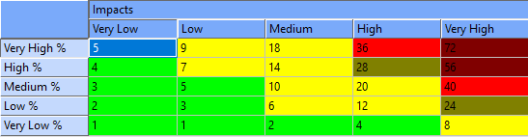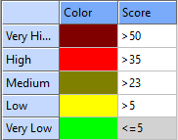
  - Project case study schedule data (KOM OMBO photovoltaic project)
The case study project is a simulation of the 26MW KOM OMBO photovoltaic project. The project is the construction of a power generation facility using photovoltaic technology with a capacity of 26 MW DC and its discharge by an underground line connected to a future substation close to the plot. A project contract is a turnkey contract. Project tasks as in Table (3) below:
Table 3: Case Study Project Activities Information
Activity Code | Activity | (Day) Duration | Start | End | Impact on Schedule
A1 | Contracting | 2 | 02-4-2018 | 03-4-2018 | From S1 to S40
A2 | Studies and engineering investigation | 48 | 04-4-2018 | 29-5-2018 | From S1 to S40
A3 | Procurement for supplies | 148 | 30-5-2018 | 18-11-2018 | From S1 to S40
A4 | Site mobilization | 15 | 16-4-2018 | 2-5-2018 | From S1 to S40
A5 | Civil work | 45 | 30-5-2018 | 21-7-2018 | From S1 to S40
A6 | Mechanical work | 85 | 10-7-2018 | 16-10-2018 | From S1 to S40
A7 | Photovoltage modules | 60 | 16-8-2018 | 24-10-2018 | From S1 to S40
A8 | Electrical work | 110 | 03-7-2018 | 07-11-2018 | From S1 to S40
A9 | Various (monitoring system, weather station, security system) | 14 | 25-10-2018 | 10-11-2018 | From S1 to S40
A10 | Operation and commission | 30 | 29-10-2022 | 26-12-2022 | From S1 to S40
  - Risk Definition
Table (4) illustrates the risks of the schedule of solar energy projects in Egypt according to the following:
Risk Code | Risks affecting the schedule | Risk Code | Risks affecting the schedule  Table 4: schedule risks data of solar energy projects in Egypt
S1 | Inflation. | S21 | Lack of open spaces for installation.
S2 | Solar energy price changes. | S22 | Absence of water resources and distance from highways, electricity networks, transmission and distribution [17].
S3 | Unproviding tax exemptions or tax deductions. | S23 | Any inaccurate site data considering risk.
S4 | Low efficiency of solar cell or solar pond. | S24 | Shortage of material resources consider risk, for example, lack of many types of silicone and other materials.
S5 | Changes of energy policies. | S25 | The expenses of choosing the wrong photovoltaic panel as well as the expenses of the wrong solar tracker.
S6 | Delays in obtaining local body approvals. | S26 | Increase capital expenditures.
S7 | Delays in procurement of construction license. | S27 | Delays in capital expenditures.
S8 | Delays in obtaining the Environmental Impact Statement. | S28 | The scarcity and high cost of climatic plants present some difficulties in determining the potential of solar energy for some specific regions.
S9 | Development of new photovoltaic systems to support energy systems | S29 | Measurements of solar resources, accurate weather data, and the development and operation of a solar farm are essential. But accurate meteorological data is scarce in some areas. [18]
S10 | Inaccurate information on net renewable electricity consumption. | S30 | Delays in acquiring the start-up and signing of contracts according to exchange rate change, inflation and various reasons like government policies changes, regulations, or economic conditions
S11 | Lack of feed-in tariffs and regulations for sustainable construction. | S31 | Delays in approval for a start-up operation.
S12 | Number of scientific publications. | S32 | Legal changing risks.
S13 | The high installation cost of solar panels. | S33 | Thefts, vandalism and social consequences of land tenure [19].
S14 | Used solar panels may need repair or replacement. | S34 | Silicon solar panels mounted on roofs may create significant environmental bottlenecks from air emissions during roof fires and from uncontrolled module waste. The design of the unit reduces fire emissions as well as efficient waste collection and recycling plans to alleviate these bottlenecks. [28]
S15 | Poor revenues estimation based on solar radiation time. | S35 | Significant environmental emissions and safety threats for saltwater storage and handling of solar ponds, [28].
S16 | Solar cells are location-sensitive, and can be difficult to use efficiently. | S36 | Production and disposal processes may have an impact on the environment and human health. (28)
S17 | Difficulty of relying solely on solar electricity, in many cases. | S37 | Financial debt to equity ratio  (Cost of Debt and Cost of Equity)
S18 | The solar power plant is highly seasonal. | S38 | Carbon dioxide emissions from energy consumption posing serious threats.
S19 | Installing solar panels on old homes can be difficult due to unique old building style and shades. | S39 | Extreme weather-related damage from hail, lightning, falling trees and defective panels [20].
S20 | Geographical conditions. | S40 | Inability to install panels in unoccupied lands.

  - Risk identification tools and techniques
Researchers used a brainstorming session for experts, exchanged views and filled out the questionnaire to determine the risks of the schedule for solar energy projects according to Figure (1):
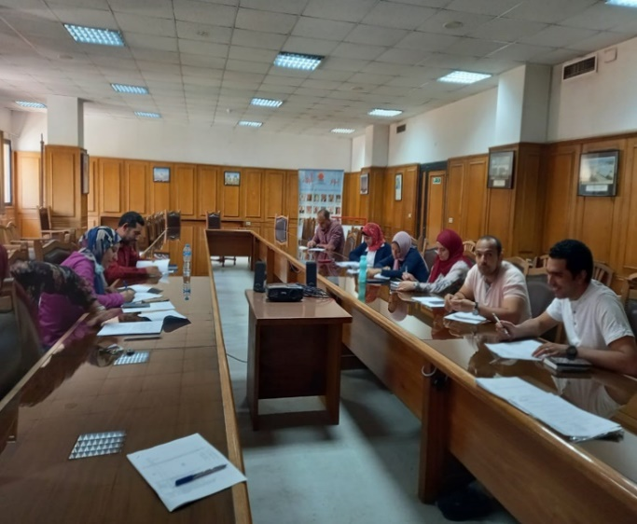 | 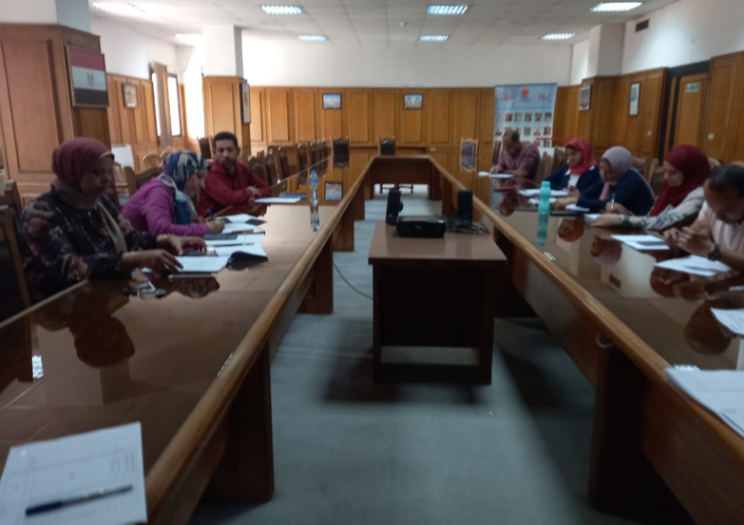
Figure 1: Experts brainstorming session
  - Quantitative Analysis
Table (5) shows the weights of experts according to the number of years of experience by placement to the first expert (years of experience 32 years)
(1)
$$W_{En}=\frac{Expert\left(n\right)experiance years}{Expert\left(1\right)experiance years}$$
$W_{En}$: Expert weight
Example: expert (2) weight= $W_{E2}=\frac{20}{36}=0.625$, expert (3) weight=$w_{E3}=\frac{16}{32}=0.5$
It shows average score with level for probability and impact of the questionnaire survey. Using these equations:
(2)
$P.R=X1-X2$
P.R: Probability Range
X1: minimum of the probability, X2: maximum of the probability
(3)
$$N.P.R=\left(X2-X1\right)+1$$
N.P.R: No. of probability range.
(4)
$$A.P=\frac{\sum_{X1}^{X2}{P}}{N.P.R}$$
A.P: Average probability, P: Probabilities
The same calculation method is used to calculate the average of the schedule.
The average levels of probability and impact in Table (5) according to Table (1).
Table 5: Expert Judgment on Variables from First Expert to Tenth Expert
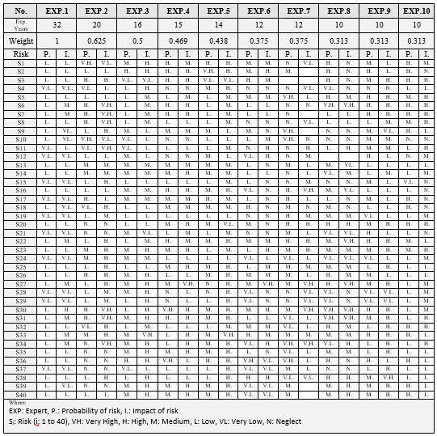
  - Quantitative Analysis
The results of the questionnaire and the brainstorming of the experts were formulated in tables (4), (5). Table (6) shows the average level of probability and severity of the impact of the risks affecting the schedule of solar energy projects. From which the average score, the level of probability and the level of severity of the impact on the schedule of each risk were obtained.
The average individual score of each expert was formulated using equation (1) to calculate the average score of probability and severity of the impact, separately [21]:
$$λ_{a}=\frac{\sum_{i=1}^{n}{β_{i}}}{N}$$
where λa is the average score (rounded to one digit); βi is the severity score determined by the expert multiplied by the expert's weight relative to his experience, and N is the number of experts. From the average score, we get the average score for probability and severity of the effect according to table (6), and get Average level of probability and severity of impact on the schedule according to table (7).
Table 6 Average score of probability and severity of impact extracted from the questionnaire
Average score for probability level | Average Probability "Numerically" | Number of probability range | Probability range | Impact on time | Number of the severity of impact on time | Average level of impact on time numerically | Average score for the severity of impact on time
V.L. | 5 | 11 | 0 - 10 | 0 - 5 | 6 | 2.5 | V.L.
L. | 20 | 19 | 11 - 29 | 6 - 9 | 4 | 7.5 | L.
M. | 40 | 21 | 30 - 50 | 10-20 | 9 | 15 | M.
H. | 60.5 | 20 | 51 - 70 | 21-40 | 20 | 30.5 | H.
V.H. | 85.5 | 30 | 71 - 100 | 41-100 | 60 | 70.5 | V.H.
Table 7: Average level of probability and severity of impact on the schedule of solar energy projects in Egypt extracted from the questionnaire
Risk | Average probability | Average Impact | Level | Risk | Average probability | Average Impact | Level
S1 | M | L | M | S21 | L | VL | L
S2 | M | L | M | S22 | L | H | H
S3 | L | L | L | S23 | L | M | M
S4 | L | L | L | S24 | L | L | L
S5 | L | L | L | S25 | L | M | M
S6 | M | H | H | S26 | L | M | M
S7 | L | H | M | S27 | L | H | H
S8 | L | L | L | S28 | VL | M | L
S9 | L | L | L | S29 | VL | M | L
S10 | M | VL | L | S30 | M | H | H
S11 | VL | L | L | S31 | L | H | M
S12 | L | L | L | S32 | L | M | M
S13 | L | L | L | S33 | L | H | M
S14 | L | L | L | S34 | L | H | M
S15 | L | L | L | S35 | L | M | M
S16 | L | L | L | S36 | M | M | M
S17 | M | L | M | S37 | VL | L | L
S18 | L | M | M | S38 | L | M | M
S19 | L | L | L | S39 | L | M | M
S20 | L | M | M | S40 | L | M | M
  - Risk Matrix Affecting the Schedule of Solar Energy Projects in Egypt:
Using Primavera risk analysis software, the researchers constructed the risk analysis matrix and classified the risks (without response, and later response) based on this matrix regarding tables (8) and (9). There are no severe risks (catastrophic) in the red color and the yellow one represent medium risks up to the point of suspending the project until negotiation, and the green color area reflects low risk.

  - Risk sensitivity
It helps to identify the risks that will have the greatest potential impact on the schedule of the project. A project's sensitivity to risk illustrates how its objectives vary proportionally to uncertainty variables [22].
Pre-mitigated risk is the current exposure to risk assuming that the risk is acceptable without specific actions taken to respond to it, but the risk that will be mitigated later is the current exposure to risk assuming that certain authorized actions will be implemented to respond to it later [23]. The authorized action is to respond to risks by avoiding, sharing, transferring, or accepting. After processing the expert data through the definition of risks and qualitative and quantitative analysis of them, the outputs of the Primavera Risk Analysis Program are shown in table (10) Prioritization of top 20 risks that have been previously responded to and have an impact on the schedule of the solar project and table (11) Prioritization of top 20 risks that have later response and an impact on the schedule of the solar project. We respond by reducing medium risks and accepting low and very low ones.
table 8: Risk analysis matrix using primavera risk analysis software without response
 | Very low | Low | Medium | High | Very High
Very High
High
Medium | S10 | S1, S2, S17 | S36 | S6,  S30
Low | S21 | S3, S4, S5, S8, S9, S12, S13, S14, S15, S16, S19, S24 | S18, S20, S23, S25, S26, S32, S35, S38, S39, S40 | S7, S22, S27, S31, S33, S34
Very Low |  | S11, S37 | S28, S29
table 9: Risk analysis matrix using primavera risk analysis software later response
 | Very low | Low | Medium | High | Very High
Very High
High
Medium | S10 | S1, S2, S17 | S6, S30, S36
Low | S21 | S3, S4, S5, S8, S9, S12, S13, S14, S15, S16, S18, S19, S20, S23, S24, S25, S26, S32, S38, S39, S40 | S7, S22, S27, S31, S33, S34, S35
Very Low |  | S11, S37 | S28, S29
Table 10: Prioritization of top 20 risks that have been previously responded to and have an impact on the schedule of the solar project
Code | Risks affecting the schedule | Rank | Code | Risks affecting the schedule | Rank
S22 | Absence of water resources and distance from highways | 24% | S40 | Inability to install panels in unoccupied lands. | 4%
S30 | Delays in acquiring the start-up and signing the contracts | 24% | S28 | The scarcity and high cost of climatic plants. | 3%
S6 | Delays in obtaining local body approvals | 24% | S4 | Low efficiency of solar cell or solar pond. | 3%
S34 | Silicon solar panels mounted on roofs may create significant environmental bottlenecks | 20% | S15 | Poor revenues estimation based on solar radiation time. | 3%
S7 | Delays in obtaining local body approvals. | 19% | S13 | The high installation cost of solar panels. | 2%
S27 | Delays in capital expenditures. | 19% | S29 | accurate meteorological data is scarce in some areas. | 1%
S31 | Delays in approval for a start-up operation. | 17% | S19 | Installing solar panels on old homes can be difficult | 1%
S33 | Thefts, vandalism and social consequences of land tenure | 15% | S9 | Development of new photovoltaic systems | 1%
S11 | Lack of feed-in tariffs and regulations for sustainable construction. | 5% | S39 | Extreme weather-related damage from hail, lightning, etc. | 1%
S36 | Production and disposal processes may impact on the environment and human health | 4% | S3 | Unproviding tax exemptions or tax deductions. | 0%
table 11: Prioritization of top 20 risks that have later response and an impact on the schedule of the solar project
Code | Risks affecting the schedule | Rank | Code | Risks affecting the schedule | Rank
S36 | Production and disposal processes may impact on the environment and human health | 18% | S4 | Low efficiency of solar cell or solar pond. | 8%
S22 | Absence of water resources and distance from highways | 17% | S11 | Lack of feed-in tariffs and regulations for sustainable construction. | 6%
S30 | Delays in acquiring the start-up and signing the contracts | 14% | S29 | Accurate meteorological data is scarce in some areas. | 4%
S6 | Delays in obtaining local body approvals | 13% | S35 | Poor revenues estimation based on solar radiation time | 4%
S31 | Delays in approval for a start-up operation. | 13% | S39 | Extreme weather-related damage from hail, lightning, etc. | 3%
S7 | Delays in procurement of construction license. | 12% | S25 | The expenses of choosing the wrong photovoltaic panel, wrong solar tracker. | 2%
S34 | Silicon solar panels mounted on roofs may create significant environmental bottlenecks | 12% | S8 | Delays in obtaining the Environmental Impact Statement. | 0%
S27 | Delays in capital expenditures. | 11%
S28 | The scarcity and high cost of climatic plants. | 9%
S33 | Thefts, vandalism and social consequences of land tenure | 9%
- Conclusions
In recent years, there has been a trend in linking project management, risk and various business activities, construction, improvement and development. Also, the trend for solar projects as a clean and renewable source of electricity generation is the current trend. In light of Egypt's interest in climate change and the use of clean energy, this paper applies to the schedule of solar energy projects in Egypt.
As a result of the research presented, we can add the following contributions to the risk assessment of the schedule of solar projects in Egypt:
1- Risk management study cannot be done individually (it cannot be conducted by an individual decision of the project manager or any responsible individual), risk management is carried out at the level of the organization as a whole and can be outsourced when needed.
2- Regarding identifying risks, we applied qualitative risk analysis using the method of combining filling out the questionnaire with a brainstorming session, which allows the exchange of opinions during filling out the questionnaire without experts influencing each other in the opinion, and the checklist can be combined with the email method to fill out the questionnaire, also various methods can be combined.
3- For the purposes of risk analysis, we applied quantitative analysis by assessing the probability and impact severity of the risk.
4- We suggest using the appropriate tools and techniques with the support of risk management programs, for example, the Primavera Risk Analysis software, in addition to different risk analysis programs that can be used, such as the Risky project and the Crystal ball program.
Risk management plays a role in managing solar projects. The main reason why projects fail to start, terminate or fail in general is mis appliance, under-application or non-application of risk management on projects. Whereas project risk management allows early identification and management of threats that may arise during project implementation quickly, effectively and efficiently. The application of solar project risk management also leads to the completion of the project in the required time or reduces the time and minimizes financial losses that may affect the success of the project, affect its quality, or lead to its failure.
The results of this research study aim to raise awareness of the role and importance of risk management and highlight the need to apply risk management to managers and support the risk management process and integrate it into the company's culture as a strategic tool. This will protect the project during the life cycle of solar projects.
The scope of this research is focusing on managing risks affecting the schedule of the solar projects. The results are valuable for solar project risk management research, and the research methodology can be used for other projects of various types of service, investment or research. The main research contribution lies in data analysis and evaluation using the proposed approach based on brainstorming session, filling out questionnaires, identifying risks, analyzing and evaluating them, creating a risk matrix and ranking risks according to their priority in taking care of using Primavera risk management software.
The results came out promising as this method will help predict the priority of risks to be considered when formulating the schedule for these projects. Overall, this paper develops an integrated framework through an expert brainstorming session, filling out the questionnaire to define and manage the risks of solar projects in Egypt, and to manage them using the Primavera Risk Management Program. In general, this framework supports risk management decision-making for this type of project. Experts are objective and rely on their experience in brainstorming and filling out the questionnaire.
The finding also provides a basis for further solar project risk management research. Future studies should look at the current state of risk management of solar projects at all stages of their life cycle. The application of risk management to other renewable energy projects such as wind projects should be considered to develop a renewable project risk management process.

List of abbreviations
SWOT | Strength, Weakness, Opportunity, Threat
SOAR | Strengths, Opportunities, Aspirations and Results
NREA | Renewable Energy Authority of Egypt
VH | Very high
H | high
M | medium
L | low
VL | very low
EXP | Expert
P | Probability of risk
I | Impact of risk
S | Risk

- Declarations
- Dr. Sarah and Dr. Mohamed have participated and contributed in (a) the conception, analysis, and interpretation of the data; (b) the drafting of the article, and (c) the approval of the final version of the research.
- This research has not been submitted to, nor is under review at, another journal or other publishing venue.
- The authors have no affiliation with any organization with a direct or indirect financial interest in the subject matter discussed in the research.
We have no conflicts or competing of interests to disclose.
Funding ‘not applicable’
Acknowledgments
The authors hereby acknowledge and recognize the efforts of the New and Renewable Energy Authority in Egypt (NREA), Dr. Mohamed Mostafa El-Khayat, CEO of NREA, Eng. Azza Mohamed Tawfik, General Manager of Training and Distribution, Eng. Amgad Al-Huwaihi, Head of Studies, Research and Testing Sector. And according to figure (2) authors acknowledge Eng. Essam El-Sayed Abdel Fattah, Director of Solar Energy Projects (20 years of experience). Eng. Raghda Saeed Marzouq Chief Testing Engineer (16 years of experience). Eng. Dareen Latif Mahmoud Electrical Engineer (15 years of experience) Eng. Abeer Mohamed Saeed Senior Test Engineer (14 years of experience) Amr Eng. Mohamed Abdel Fattah Senior Engineer and PV Developer (12 years of experience) Eng. Asmaa Fouad Shehab Senior Electrical Engineer (12 years of experience) Eng. Mohamed Hamed Ashour Head of PV Department (12 years of experience) Eng. Omar Fathy Emara Testing Engineer (10 years of experience) Eng. Rasha Abdel Halim Mohamed PV Engineer (10 years of experience).

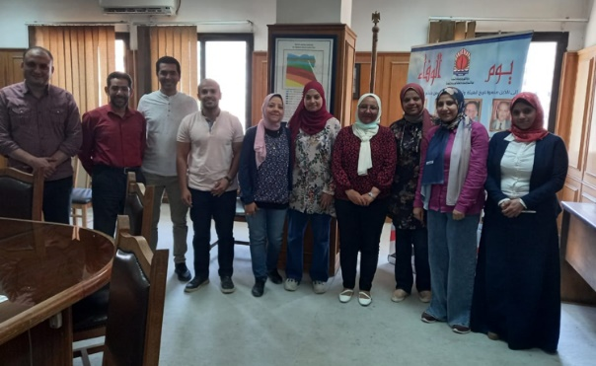
Figure 2: Acknowledgment for Experts

References

[1] | A. P. A. S.-W. a. L. G. A. Kuriqi, "Water-energy-ecosystem nexus: balancing competing interests at a run-of-river hydropower plant coupling a hydrologic-ecohydraulic approach," energy Conversion and Management, vol. vol. 223, no. article 113267, 2020.
[2] | I. G. A. J. G. M. D. L. S. Fares M’zoughi, "Fuzzy Airflow-Based Active Structural Control of Integrated Oscillating Water Columns for the Enhancement of Floating Offshore Wind Turbine Stabilization," International Journal of Energy Research, vol. 23 pages, no. Article ID 4938451, 2023.
[3] | I. M. F. A. P. e. a. Ahmad, "A regressive machine-learning approach to the non-linear complex FAST model for hybrid floating offshore wind turbines with integrated oscillating water columns," Sci Rep 13, 2023. [Online]. Available: https://doi.org/10.1038/s41598-023-28703-z. [Accessed 2023].
[4] | R. Yin, " Case Study Research: Design and Methods, 4th ed.,," Sage Publications, Newbury Park, CA., 2009.
[5] | A. M. M. I. &. A. Y. Keshk, " Special studies in management of construction project risks, risk concept, plan building, risk quantitative and qualitative analysis, risk response strategies," Alexandria engineering journal, vol. 57(4), no. 3179-3187, 2018.
[6] | D. S. G. &. L. P. E. Baccarini, "Management of risks in information technology projects.," Industrial Management & Data Systems., 2004.
[7] | D. Hillson, " Extending the risk process to manage opportunities.," International Journal of project management, vol. 20(3), pp. 235-240., 2002.
[8] | G. M. C. N. J. G. K. J. H. C. R. A. I. G. A. H. R. L. N. I. G. E. L. .. &. S. S. N. Mace, "Quantification of extinction risk: IUCN's system for classifying threatened species," Conservation biology, vol. 22(6), pp. 1424-1442, 2008.
[9] | K. Heldman, "Project manager's spotlight on risk management," John Wiley & Sons, 2005.
[10] | P. R. A. B. &. A. A. Shedden, "Risk Management Standards-The Perception of ease of use.," Journal of Information System Security, vol. 6(3), 2010.
[11] | F. S. R. A. N. &. N. N. Shahmiri, "Offering a Model to Identify the Tools to Formulate Innovation Strategy Using Integrating Innovative Capabilities and Decision Making Methods," Research Notes in Information Science, vol. Research Notes in Information Science, pp. 1-11, 2012.
[12] | A. M. M. I. &. A. Y. Keshk, "Special studies in management of construction project risks, risk concept, plan building, risk quantitative and qualitative analysis, risk response strategies," Alexandria engineering journal, vol. 57(4), no. 3179-3187, 2018.
[13] | K. Heldman, Project manager's spotlight on risk management, John Wiley & Sons, 2005.
[14] | J. Uzulāns, "Project Risk Register Analysis And Practical Conclusions," Practice and Perspectives, vol. 414, p. 16, 2015.
[15] | P. Hopkin, "Fundamentals of risk management: understanding, evaluating and implementing effective risk management," Kogan Page Publishers, 2018.
[16] | K. Jugdev, "Learning from lessons learned: Project management research program.," American Journal of Economics and Business Administration, vol. 4(1), p. 13, 2012.
[17] | "Solar Research," [Online].
[18] | M. A. R. M. H. A. A. S. Z. Bahaa Elboshy, "A suitability mapping for the PV solar farms in Egypt based on GIS-AHP," Ain Shams Engineering Journal, p. 12, 2022.
[19] | C. G.-B. C. N. &. M. Y. Norberto, "Systematic analysis of factors affecting solar PV deployment," Journal of Energy Storage, pp. 6, 163-172., 2016.
[20] | H. Sogukpinar, "A new perspective to the conventional solar pond technology," environmental progress and sustanble energy, p. 11, 2020.
[21] | W. Banda, "An integrated framework comprising of AHP, expert questionnaire survey and sensitivity analysis for risk assessment in mining projects," Vols. 14(3), 180-192., 2019.
[22] | M. Yogi, "Primavera Risk Senstivity Analysis with Tornado Diagram," Management Yogi, 27 Jun 2015. [Online].
[23] | "www.rmcapability.com," Risk Management Capability ltd, 2013. [Online].
[24] | M. O. Farshad Farahbod, " Experimental evaluation of collection, thermal, and conductivity," Energy Science and engineering , p. 11, 8 August 2018.
[25] | *. E.-S. H. Hegazy Rezk a, "A new MATLAB/Simulink model of triple-junction," Ain ShamsEngineering Journal, p. 9, 2014.
[26] | B. K, ") Models for determination of solar energy potential.," Energy Exploration &Exploitation 26(5): , p. 281–292, 2008.
[27] | H. W. ,. S. X. Qi Wu, "Effect of heat extraction on the thermal efficiency of salt," Energy Exploration & Exploitation, p. 14, 2019.
[28] | R. R, "RClimate change and oil depletion in," Energy Exploration & Exploitation, p. 21(1), 2003.
[29] | H. A. a. H. SH, " Utilizing solar energy instead of fossil fuels as domestic energy (case study: Dehloran city, Ilam province, Iran)," Energy Exploration & Exploitation, p. 389–402., 2012.
[30] | K. P. L. A.-R. A. A. K. L. V. &. S. E. Ranabhat, "An introduction to solar cell technology," Journal of Applied Engineering Sciences, pp. 14(4), 481–491. doi:10.5937/jaes14-10879, 2016.
[31] | K. M. &. H. R. Fetyan, "Performance evaluation of on-grid PV systems in Egypt," Water Science, pp. 35(1), 63-70., (2021).
[32] | D. &. S. P. Hillson, Practical project risk management: The ATOM methodology, Berrett-Koehler Publishers, 2020.

